MODULE 03 AND 04

- Simulate a small network with switches and multiple devices. Use ping to generate traffic and observe the MAC address table of the switch. Capture packets using Wireshark to analyze Ethernet frames and MAC addressing.

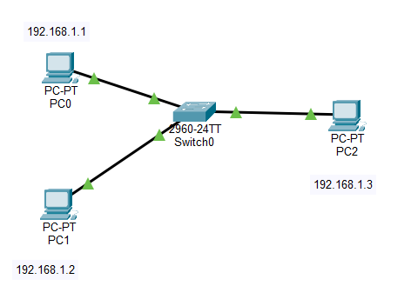
Connected 3 devices and a switch.
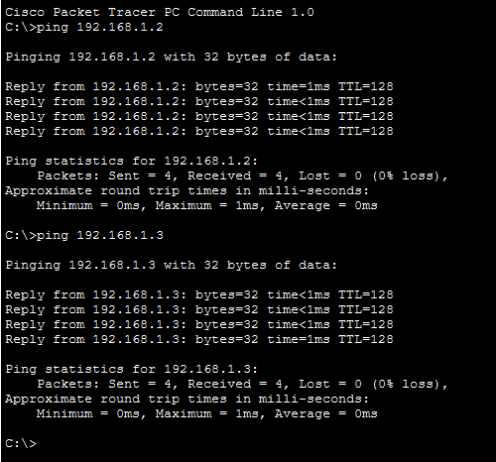
Pinging PC 2 from PC1.
Then pinging PC3 from PC1.
Then pinging PC1 from PC2.
Then pinging PC3 from PC2.

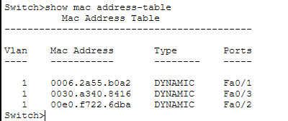
Then observed the MAC address table using show mac address-table command.
Switch :
- Learns PC0 MAC → Fa0/1
- Forwards frame to PC1
- Learns PC1 MAC → Fa0/2
- Stores in MAC table
So switch builds mac address table automatically.

Capturing packets using Wireshark and analyzing ethernet frames and MAC addressing.
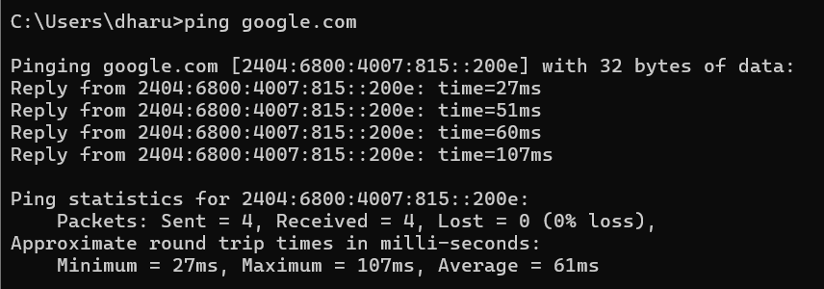
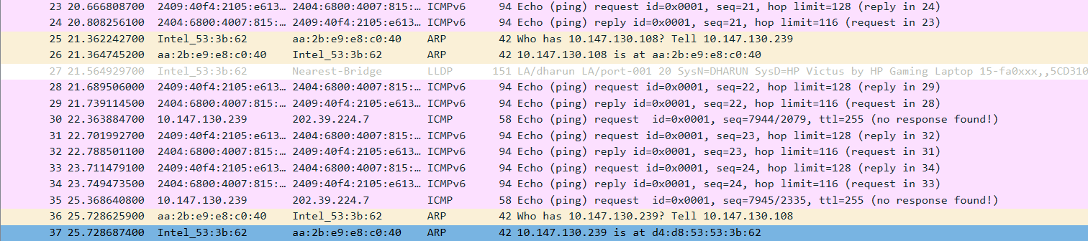

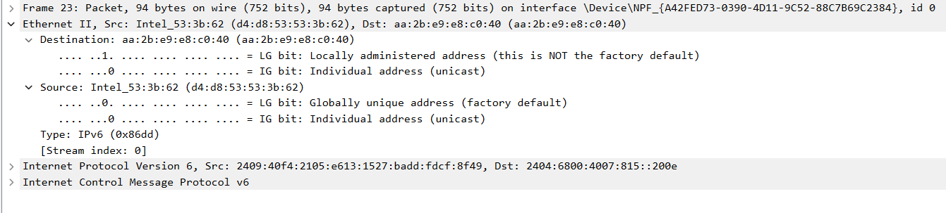

Inference:
- Ping command generated ICMPv6 Echo Request and Echo Reply packets.
- Each ping request received a corresponding reply.
- In Wireshark, Ethernet II frames were observed.
  - Ethernet frame contained:
    - Source MAC address – Here this is the PC’s physical address.
    - Destination MAC address – Here it is the default gateway that is Router’s MAC address not the google server MAC address.
    - EtherType (IPv6)
- The IP packet was encapsulated inside the Ethernet frame.
- The ICMPv6 packet was encapsulated inside the IP packet.
_________________________________________________________________________________
- Capture and analyze Ethernet frames using Wireshark. Inspect the structure of the frame, including destination and source MAC addresses, Ethertype, payload, and FCS. Use GNS3 or Packet Tracer to simulate network traffic.

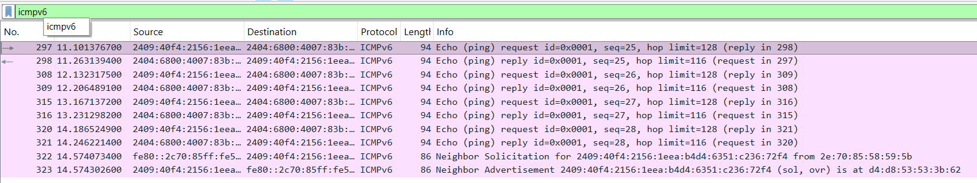

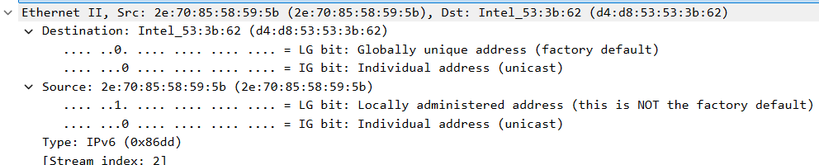

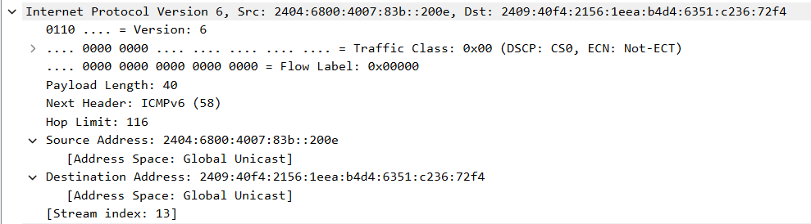

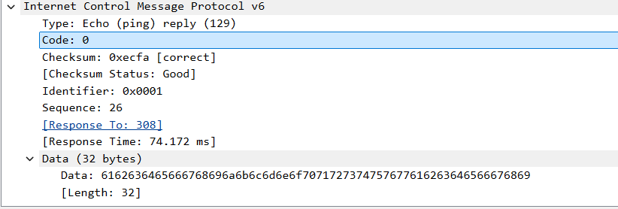

- Packets were captured using Wireshark while generating traffic using ping.
- Ethernet II frames were observed.
- Each frame contained destination MAC address and source MAC address.
- EtherType field indicated the protocol inside the Ethernet frame (IPv6).
- The payload contained the IP packet and ICMP echo request/reply messages.
- Frame Check Sequence (FCS) is used for error detection but is usually not visible in Wireshark.
- This shows that Ethernet frames encapsulate IP packets for transmission over the network.

Simulation of network traffic using cisco packet tracer:
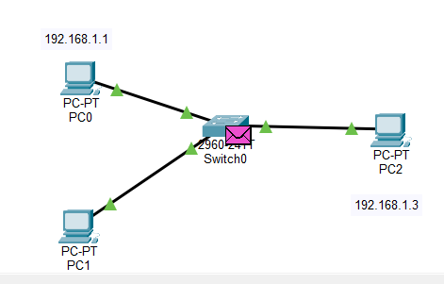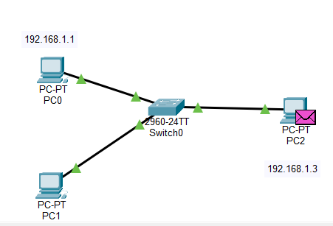
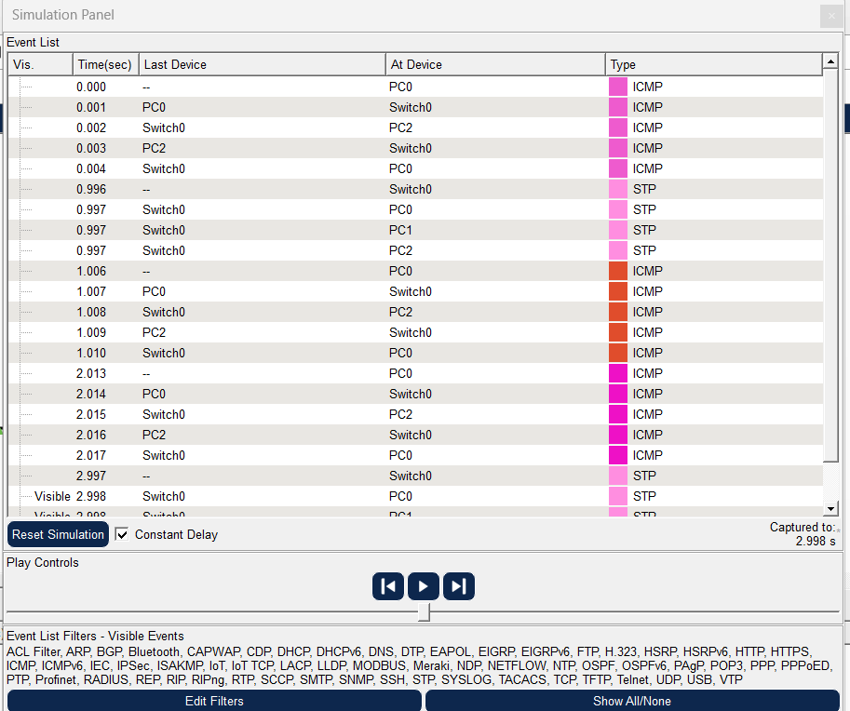
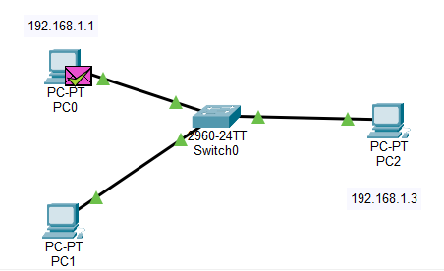

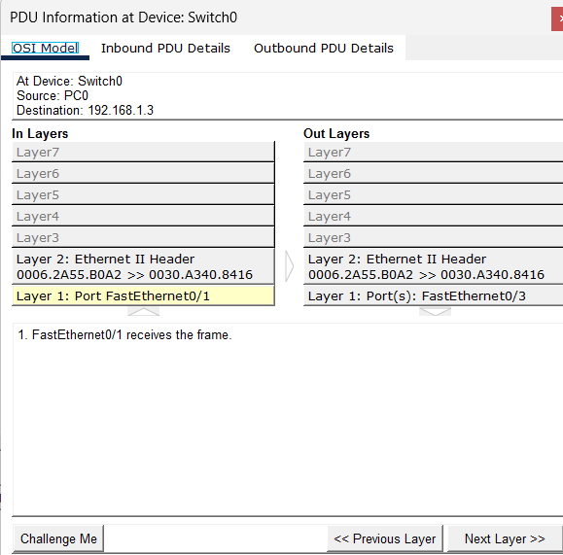

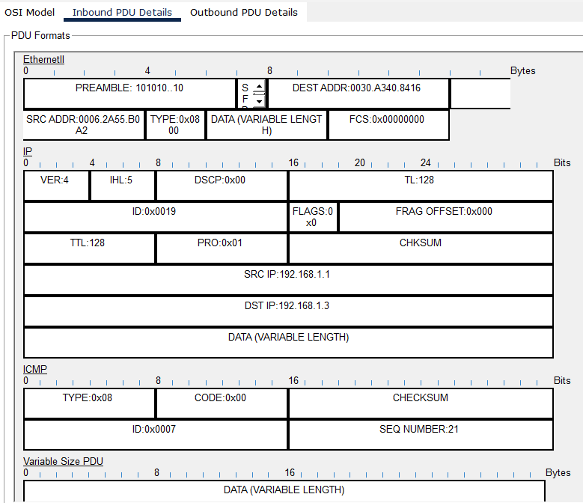
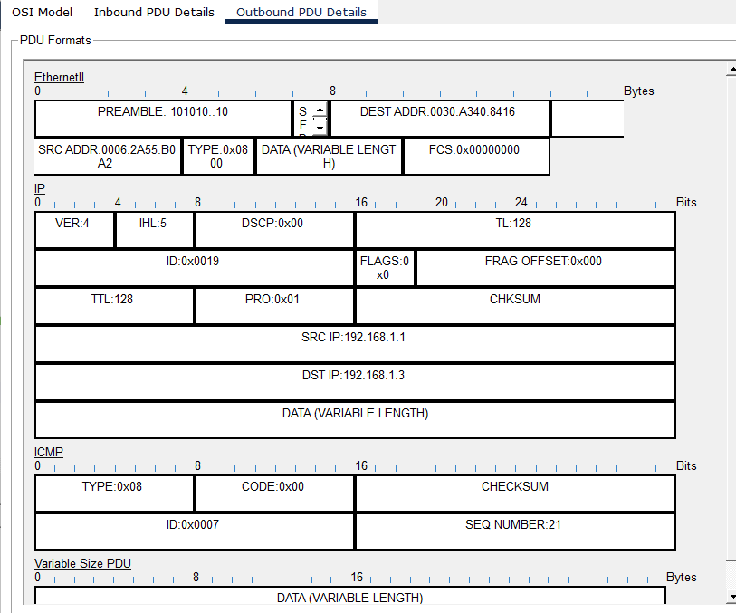

When PC0 ping PC2:
1. PC0 sends ARP Request (Broadcast)
2. PC2 sends ARP Reply (Unicast)
3. PC0 sends ICMP Echo Request
4. PC2 sends ICMP Echo Reply
Switch forwards frames based on MAC address table.

- Configure static IP addresses, modify MAC addresses, and verify network connectivity using ping and ifconfig commands.

Configured static ip addresses manually:
PC0: 192.168.10.1
PC1: 192.168.10.2
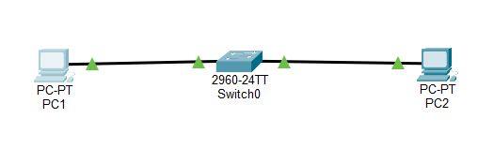
MAC Address of PC0 before modifying: 000C.85DC.66B2
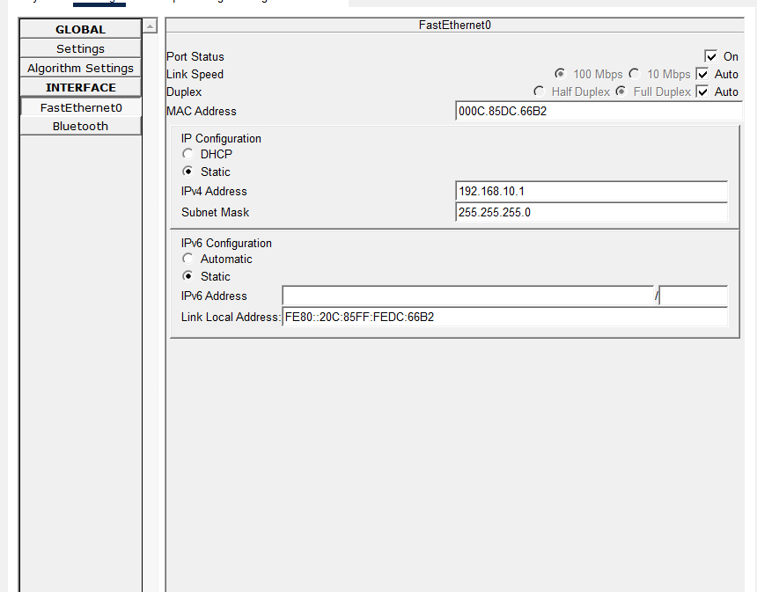

MAC Address of PC1 after modification: 00AA.BBCC.DD01
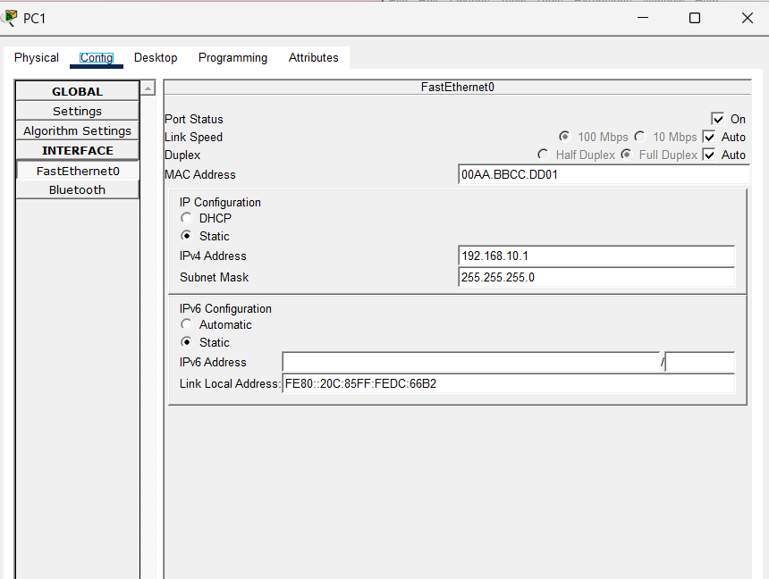

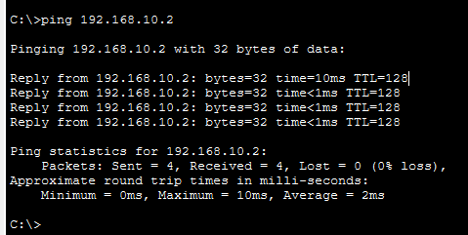

We can infer from above that after MAC Address modification also when ping is done the packets were received properly.

- Troubleshoot Ethernet Communication with ping and traceroute → Using Cisco Packet Tracer.

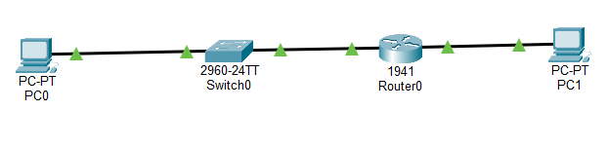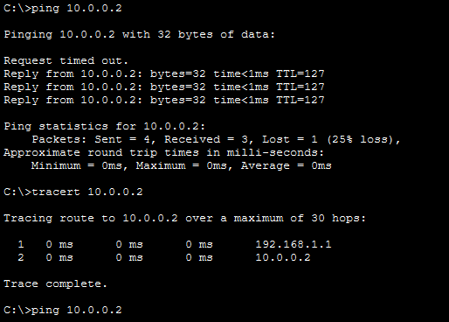

Now router interface is turned off.
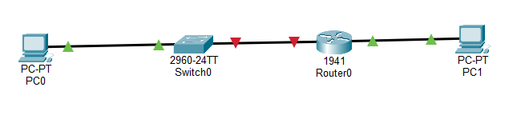
Now troubleshooting process:
Ping the destination ip.
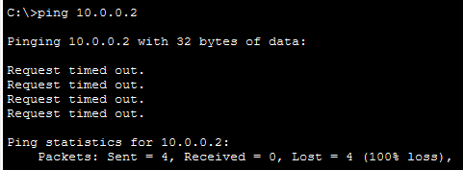
Traceroute the destination ip.
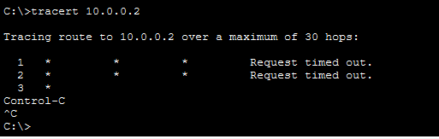
Find the default gateway using ipconfig.
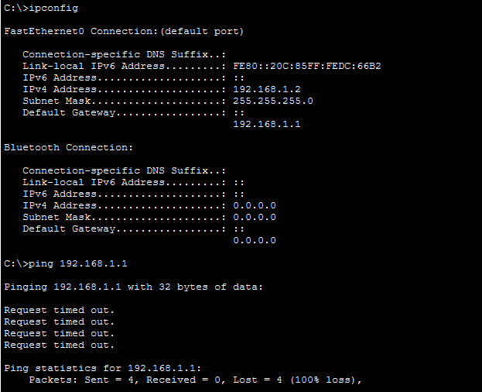

Then ping the default gateway ip.
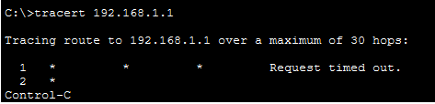
So from here we can identify the default gateway has some error that is the router has some error.
- Create a simple LAN setup with two Linux machines connected via a switch.
Ping from one machine to the other. If it fails, use ifconfig to ensure the IP addresses are configured correctly. Use traceroute to identify where the packets are being dropped if the ping fails.

